Flipboard Like HTML5 App – FrontEnd Assembly

Project Overview

Client wants to develop a Hybrid mobile application built in HTML5/JS/CSS, which will be deployed to iOS and Android - Phone & Tablet sized.
This mobile application will aggregate RSS data from external sources, social media content, and internal content served via REST API, similar as Flipboard.
For internal content, we'd like to seek an existing content management sytem that fits our client's requirement to reduce the development effort.

In this module assembly, we will build mobile application based on PhoneGap and HTML5.

Requirements

General Approach

Please see section 2 of the ADS.

Social Network Integration

Facebook
Facebook login will be done using the Javascript SDK Web Login process. It is described in good detail at https://developers.facebook.com/docs/facebook-login/login-flow-for-web/

The only thing we need beforehand for this process is the Facebook AppId which can be generated in the App Dashboard https://developers.facebook.com/apps/

Note that in the case of Facebook, we do not need to store the retrieved accessToken at our end. The JavaScript SDK takes care of storing the accessToken at their end.

Sharing article on FB will also be done using the JavaScript SDK. The FB.ui method will be used where method is 'feed'.
See the example at https://developers.facebook.com/docs/javascript/reference/FB.ui
The mapping between Article fields and FB.ui fields for sharing is quite obvious.

The current user's FB news feed is accessible by making a call to the /me/home endpoint. This can also be done using Javascript SDK using the FB.api call. See https://developers.facebook.com/docs/graph-api/reference/user/home/
Since the FB news feed is also displayed like articles, the mapping from FB response and Article fields is as follows:
FB JSON Response Field | Article
from.name | author
link | link
name | title
picture | image
message | description

Twitter
Twiiter OAuth login is described at https://dev.twitter.com/docs/auth/implementing-sign-twitter
Twitter does not provide any client side libraries for performing the login. So our app will have to do the OAuth dance ourselves. The steps provided in the above link are quite comprehensive though and can be followed by developer.

A description of doing general OAuth on PhoneGap is provided at http://phonegap-tips.com/articles/google-api-oauth-with-phonegaps-inappbrowser.html
Note the usage of the a localhost address for the callback url, which we just use to get the OAuth response data and then close the InAppBrowser.
The access-token received must be stored on the device in localstorage.

Twitter API calls must then be authenticated using the custom Authorization header used by Twitter. It is described at https://dev.twitter.com/docs/auth/authorizing-request. The header contains many fields; the Access-token is what we have stored on device and the other fields are all created on a per-request basis.

Twitter Share or Tweets can be performed either by using their in-built Tweet Button https://dev.twitter.com/docs/tweet-button or more generally using the statuses/update API endpoint. https://dev.twitter.com/docs/api/1.1/post/statuses/update. The former can be used if we are willing to use their Tweet Button UI and the latter must be used if we want to use our own custom Tweet Button UI.

Twitter Feeds can be read simply by using the statuses/user_timeline API endpoint. It is described at https://dev.twitter.com/docs/api/1.1/get/statuses/user_timeline
Since the Twitter news feed is also displayed like articles, the mapping from FB response and Article fields is as follows:
Twitter JSON Response Field | Article
user.name | author
entities.urls[0].expanded_url  (if entities.urls has length > 0) | link
text | title
user.profile_image_url | image
text | description

LinkedIn
For LinkedIn, the OAuth login process is defined at https://developer.linkedin.com/documents/authentication. It is also a normal OAuth implementation almost exactly the same as the Twitter OAuth (see above).

For LinkedIn, we only need the Share functionality which is covered at https://developer.linkedin.com/documents/share-api

NOTE: To make HTTP calls to arbitrary domains, we need to whitelist them. See http://stackoverflow.com/questions/18263578/ajax-request-from-phonegap-android-fails

UI Mapping

Home Page (Dashboard)
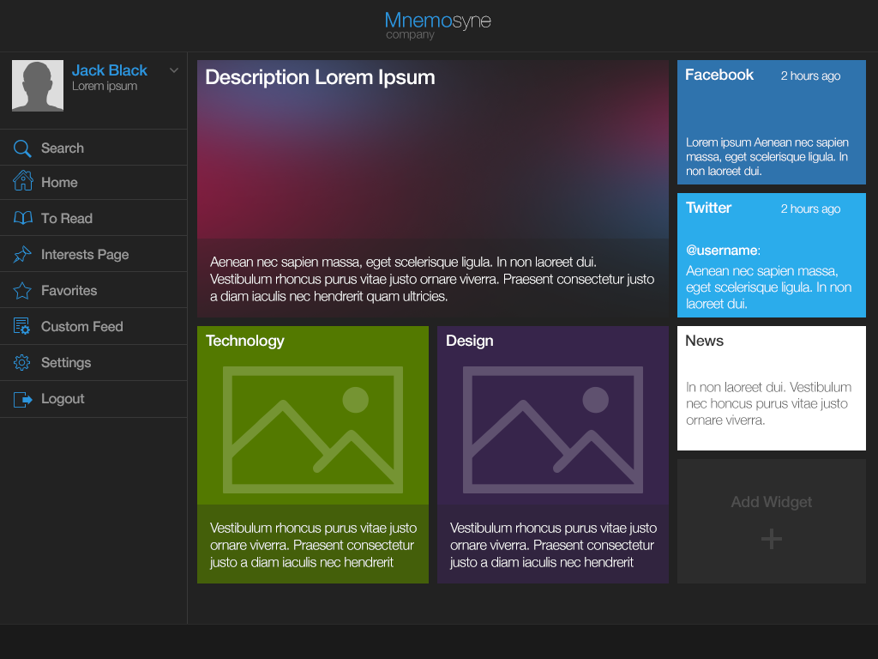
- Use the getCategories API to get all the categories.
- Use the getInterests API to get the categories of interest for the user (if logged in).
- Get first 2 interests (or categories if not logged in) and show them in the bottom 2 tiles. (in the image above, Technology and Design). The image to be shown is the category.image and the text below the image is the category.description.
- The Facebook and Twitter feeds are described above.
- The main tile can be shown by calling getArticlesForCategory for a random category and binding the article title and description to the tile. (In Flipboard this tile is for Flipboard picks, but we do not have any such concept in our system for now)
- On flip, the next n interests can be shown on tiles just like above.

To Read
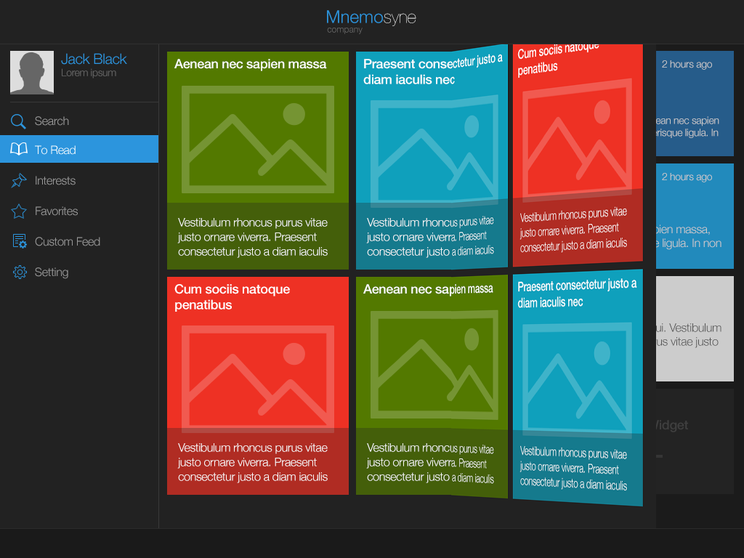
- Use the getToRead API to get all the to read articles. Use the paging feature.
- Each article can be displayed using the article.title as the header and the first 200 characters of article.description as the text.
Note that articles do not have photos. Even in Flipboard most articles are shown without photos. Showing images would require the custom conversion process of each article page. This is an open item at http://apps.topcoder.com/forums/?module=Thread&threadID=816845&start=0
- On page flip we can use the pagination feature of the getToRead API to show the next page of tiles.

View Category
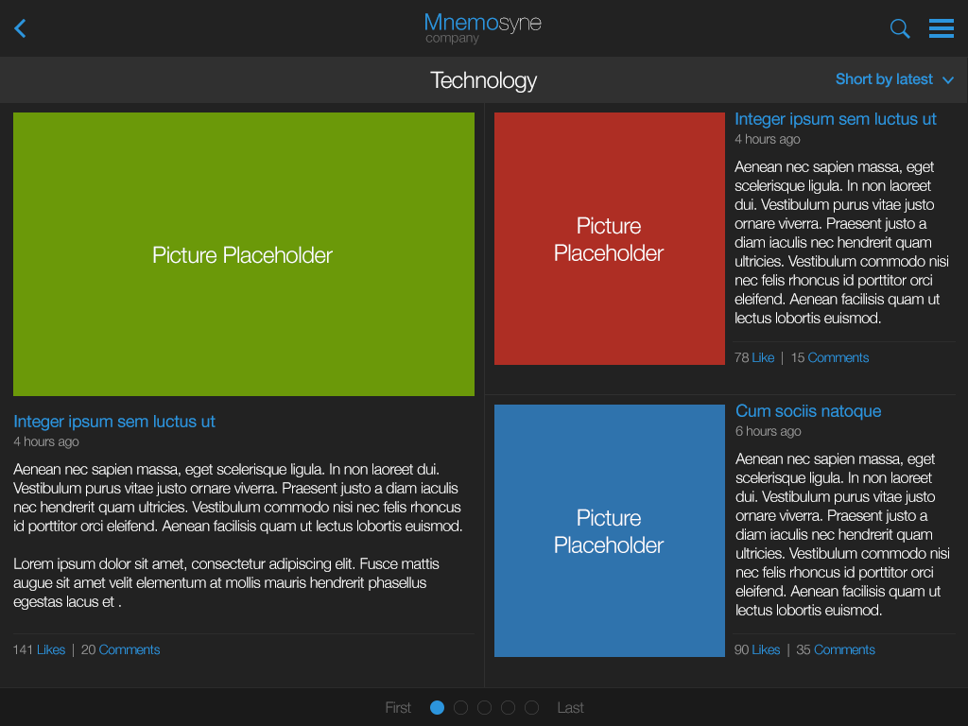
- Use the getArticlesForCategory with the paging parameters set and optionally the sorting parameters.
- Each article can be displayed using the article.title as the header, the first 200 characters of article.description as the text, the article.pubDate used to display the recency of the article and the total_likes and total_comments for the namesake fields.
Note that articles do not have photos. Even in Flipboard most articles are shown without photos.
- On page flip we can use the pagination feature of the getArticlesForCategory API to show the next page of tiles.

View Article
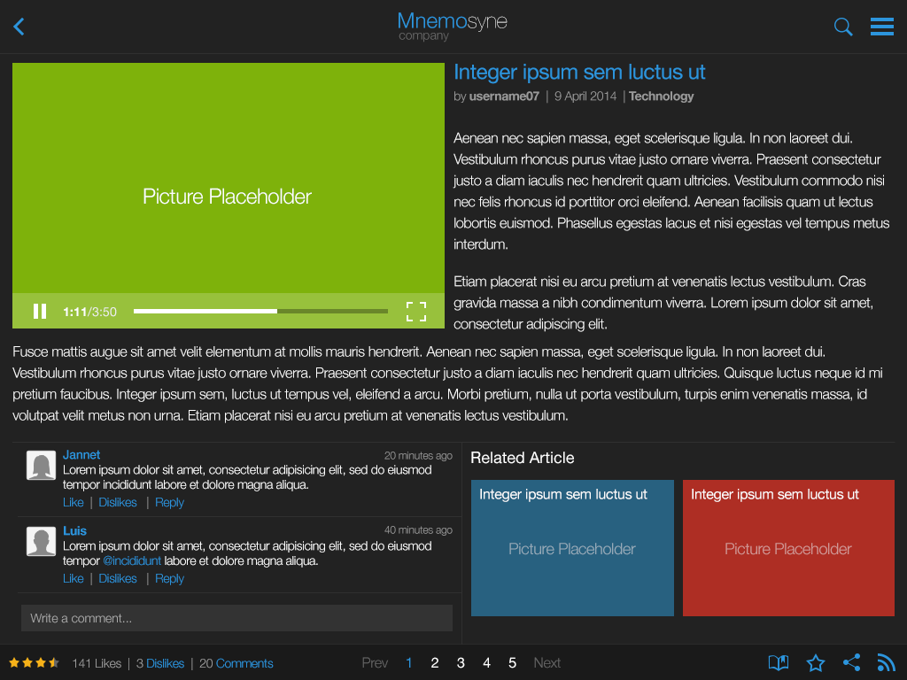
- Use the getArticle call for getting all the details of the article.
- For displaying the article content itself, the entire article will be loaded into an iframe with the src set to articleHeader.link
If however the articleHeader.is_video is true, we will use the HTML5 video tag to load the video at articleHeader.link.
Note that articles do not have photos. Even in Flipboard most articles are shown without photos.
- The mapping of the remaining Article fields to this page is straightforward.

Favorites page
The user's favorite articles can be retrieved using the getFavorites API call. The flipping can again be done using the paging calls. The mapping of the ArticleHeader fields and the page is straightforward. The favorites can be set and deleted using the saveFavorite and deleteFavorite calls.

Interests page
The user's interest categories can be retrieved using the getInterests API call. The mapping of the Category fields and the page is straightforward. The intrests can be set and deleted using the saveInterest and deleteInterest calls.

Search page
There is no search page in the storyboards. But a search page similar to that of Flipboard can be implemented by making call to the search API call.

Login and Logout
Login and Logout pages will be done using the namesake REST API calls.
The SessionId received after the login API call should be stored in the localStorage.
The Access-tokens received after the OAuth login to social networks must also be stored on th device in localStorage.
For logout, one or all of these values must be removed from localStorage.

Sharing by email

We will use the Cordova plugin email composer for sharing by email feature. https://github.com/katzer/cordova-plugin-email-composer
We will use the window.plugin.email.open method with the article information in the body and the subject, like so:
window.plugin.email.open({
subject: article.title,
body: article.link
});

We must check if email service is available and if not then show modal error popup.
window.plugin.email.isServiceAvailable(
function (isAvailable) {
// alert('Service is not available') unless isAvailable;
}
);

Other Requirements
See ADS section 2 for cross cutting requirements like logging, configuration, exception handling, internationalization etc.

Submission Deliverables
- Source Code
- Deployment Guide to verify the submission.

Technology Overview

Application Technologies
- HTML5
- PhoneGap 3
- BootStrap 3.1
- jQuery 2.0
- XHR
- JavaScript
- CSS
- localstorage
- Web SQL

Project Dependencies

Assemblies
Flipboard-Like HTML5 App – REST API Assembly

Components
None

Third Party Libraries
See section 1.4.1

Project Deliverable Details

Source code setup
Standard TopCoder Assembly Contest source code setup

Build Setup
Standard TopCoder Assembly Contest ant based build setup

Final Submission
- For each member, the final submission should be uploaded to the Online Review Tool.
- The final submission will be reviewed using the standard Online Review Assembly Scorecard.

